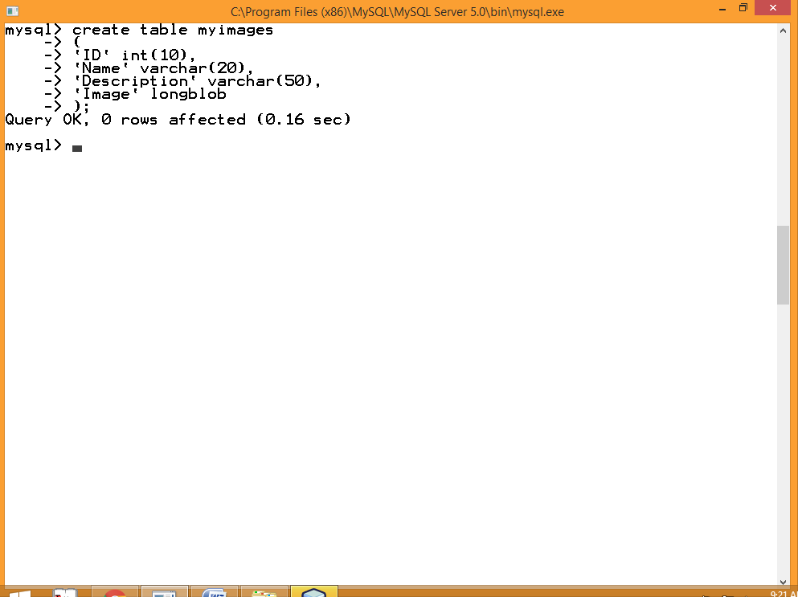

import java.awt.Color;
import java.awt.Image;
import java.awt.event.ActionEvent;
import java.awt.event.ActionListener;
import java.sql.Connection;
import java.sql.DriverManager;
import java.sql.ResultSet;
import java.sql.Statement;
import javax.swing.*;

public class Imagestore extends JFrame{
JButton button ;
JLabel label;
JTextField jtf;

public Imagestore(){
super("retrieve image from database in java");

button = new JButton("Retrieve");
button.setBounds(250,300,100,40);

jtf = new JTextField();
jtf.setBounds(360,310,100,20);

label = new JLabel();
label.setBounds(10,10,670,250);

add(button);
add(label);
add(jtf);

button.addActionListener(new ActionListener() {

@Override
public void actionPerformed(ActionEvent e) {

try{
Connection con = DriverManager.getConnection("jdbc:mysql://localhost:3306/db_images","root","1234");
Statement st = con.createStatement();
ResultSet rs = st.executeQuery("select * from myimages where ID = '"+jtf.getText()+"'");
if(rs.next()){
byte[] img = rs.getBytes("Image");

//Resize The ImageIcon
ImageIcon image = new ImageIcon(img);
Image im = image.getImage();
Image myImg = im.getScaledInstance(label.getWidth(), label.getHeight(),Image.SCALE_SMOOTH);
ImageIcon newImage = new ImageIcon(myImg);
label.setIcon(newImage);
}

else{
JOptionPane.showMessageDialog(null, "No Data");
}
}catch(Exception ex){
ex.printStackTrace();
}

}
});

setLayout(null);
setDefaultCloseOperation(JFrame.EXIT_ON_CLOSE);
getContentPane().setBackground(Color.decode("#bdb76b"));
setLocationRelativeTo(null);
setSize(700,400);
setVisible(true);
}

public static void main(String[] args){
new Imagestore();
}
}

